Azure Test Plans

There are different types of Testing:
- Manual & Exploratory Testing
Tester freely explores the app without scripts + user acceptance
- Automated Testing
Scripted tests for regression and CI/CD validation.
Examples:
Unit Tests: [TestMethod] public void CalculateTotal_ValidInput_ReturnsCorrectSum()
UI Tests: Selenium script to validate login functionality.
API Tests: Postman/Newman tests for REST endpoints.

- Traceability
Link tests to requirements for compliance.
takes a look on the requirements in Azure Board and test

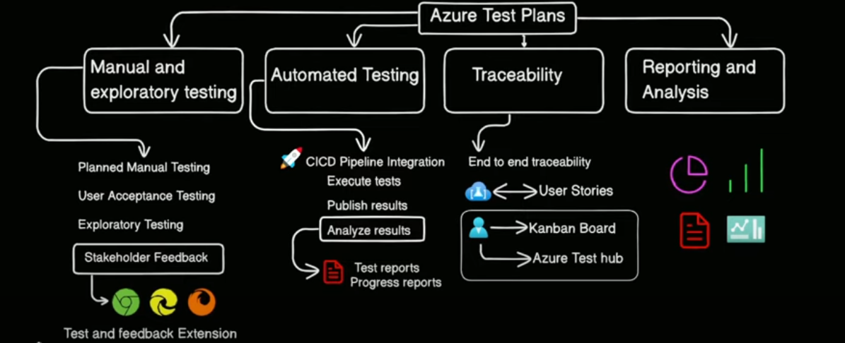

Testing Components:
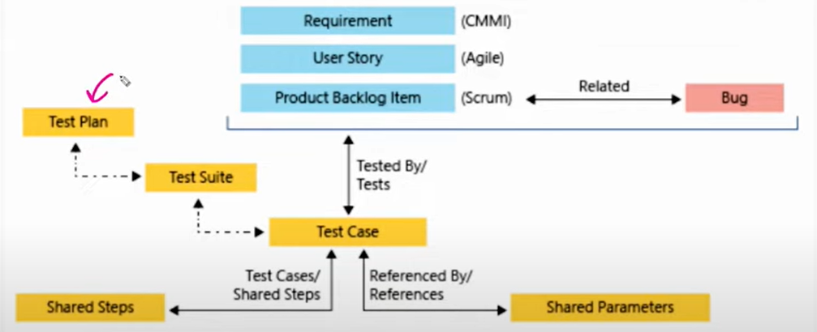
a Test Plan can (and often does) contain multiple Test Suites.
A Test Suite can (and often does) contain multiple Test Cases.

Test Plan
A high-level document outlining the scope, objectives, resources, schedule, and approach for testing.
It ensures all aspects of the software are tested.

Test Suite
A collection of related test cases grouped by functionality, module, or testing type (e.g., "Login Module," "API Tests").
Multiple test suites may be included in a test plan to cover different aspects of the system.

Example:
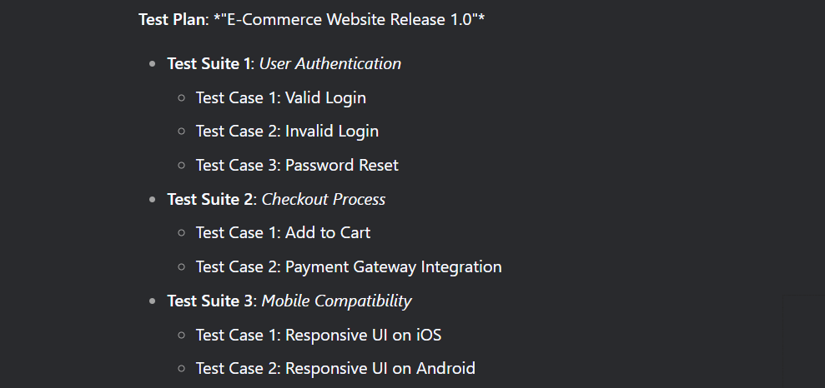

You need to enable Test Plans on your Azure DevOps Organization
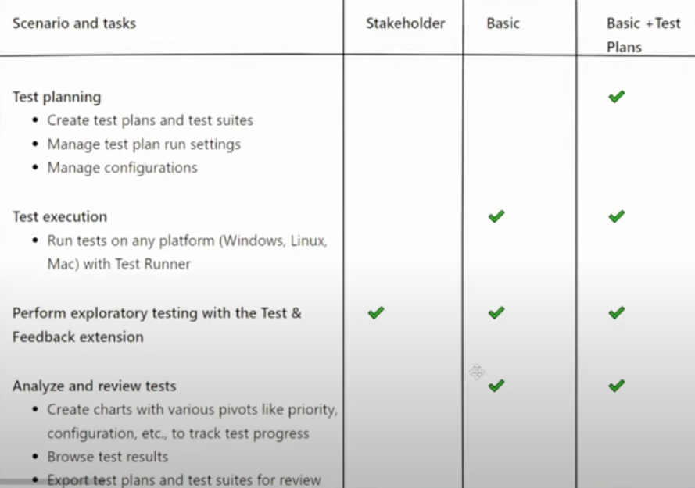

Testing planning VS Test execution
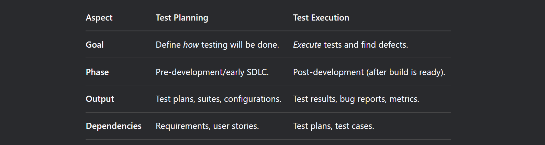

Artifact

You create two Pipelines
- CI Pipeline -> build the application then create Artifact
- CD pipeline -> Get the new Artifact and publish to App Service (needs permissions)

Each artifact is determined as the building tool like .net , python , java (maven) , nodejs (npm).
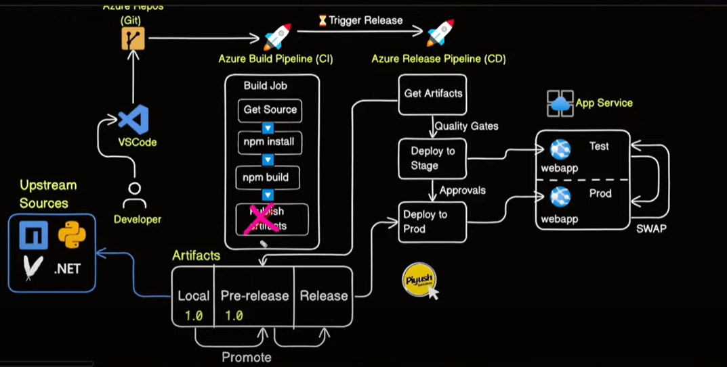

Artifacts can be Organization scoped -> (default created artifact) or Project Scoped (you create artifacts inside project )
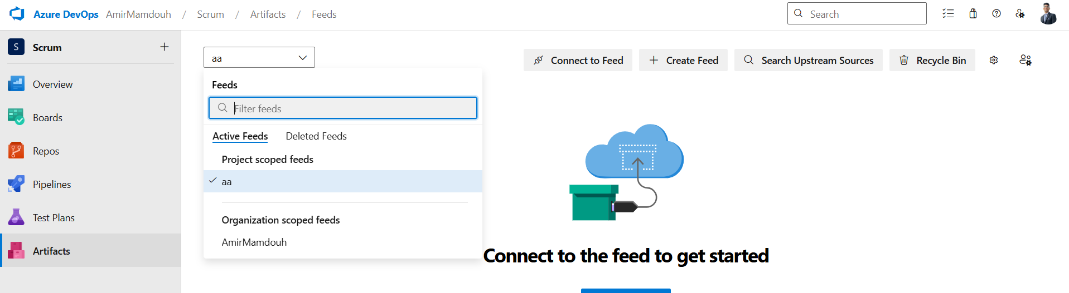
Create the artifact from your nodejs application
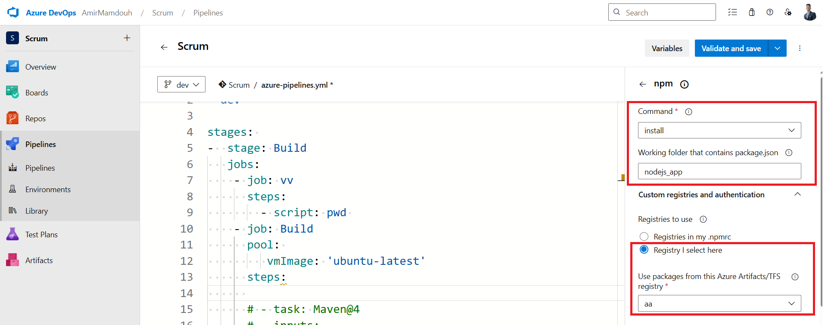

The pipeline is succeed
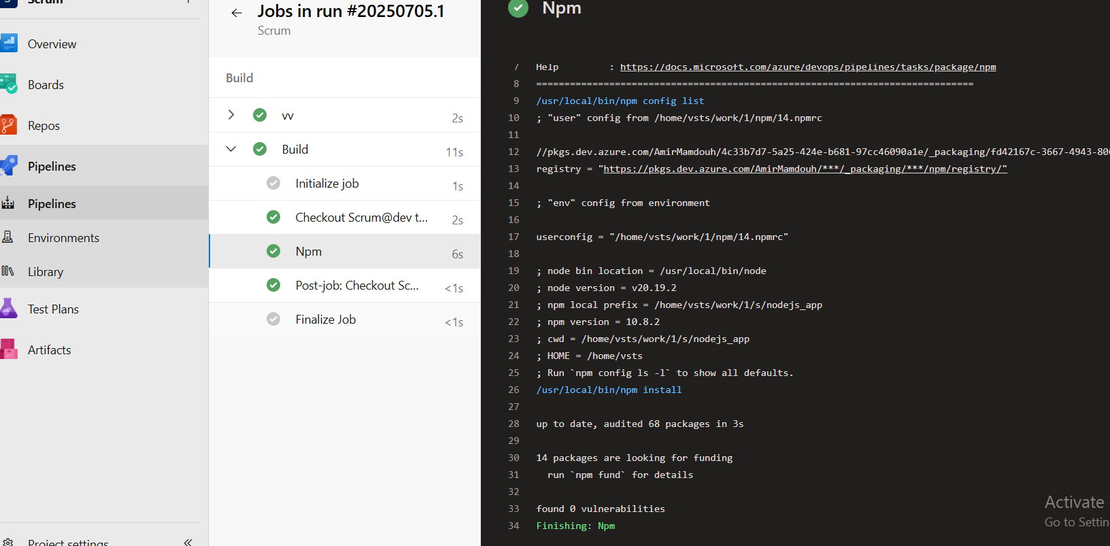

NOTE:
What is Build Service User?
In Azure DevOps, the Build Service User is a security identity used by pipelines to authenticate and perform tasks (e.g., fetching code, deploying artifacts, running scripts).

Pipeline Build Service user should has role contributor to the artifact
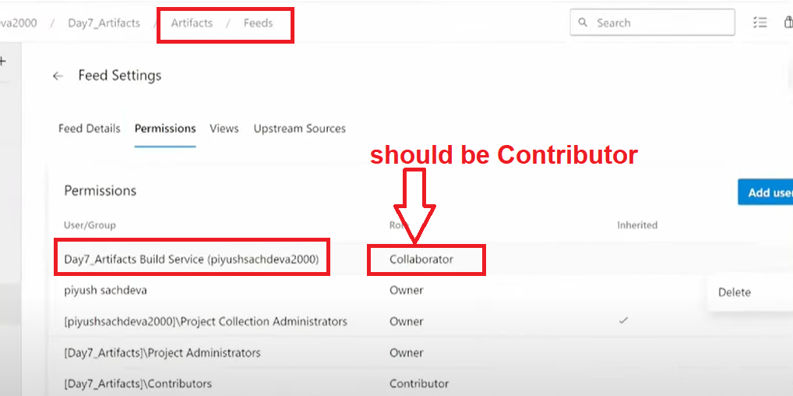
In my case
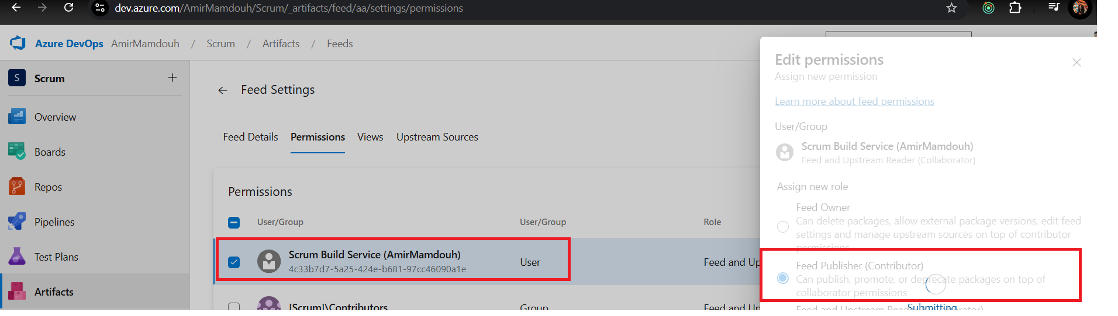

What is Service connection?
A Service Connection in Azure DevOps is a secure link between your pipeline and an external service (like Azure, npm, Docker Hub, or AWS). It stores authentication details (credentials, tokens, or certificates) so your pipeline can interact with that service without hardcoding secrets.

Examples of Service connections:
- Azure Resource Manager (ARM) → Purpose: Deploy resources to Azure (e.g., VMs, Web Apps, AKS).
- Docker Registry → Purpose: Push/pull Docker images to/from registries (ACR, Docker Hub).
- npm Registry (Azure Artifacts) → Purpose: Publish npm packages to a private feed.
- GitHub → Purpose: Trigger pipelines from GitHub events or check out code.

Agent Pool

NOTE:
You can specify Agent pool for your Azure DevOps Pipeline -> VMs responsible for running pipelines

Agent Pool (logical)
It just groups agents and lets you control security (which project can use which pool).

Agent (software)
A small listener service installed on a VM / machine.
When a pipeline job starts, Azure DevOps picks an idle agent from the pool, gives it the job, and the agent executes the steps.

VM / Machine (physical / virtual)
Where the agent process actually runs. For Microsoft-hosted pools this VM is created and deleted automatically; for self-hosted pools you manage it.
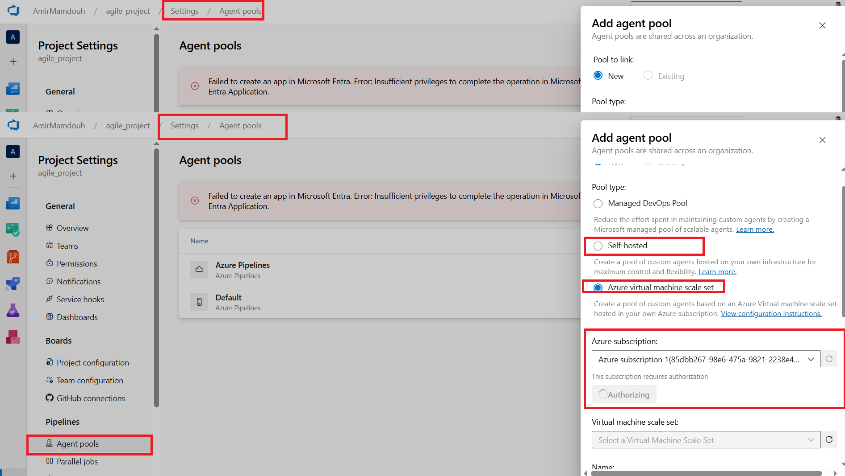
NOTE:
- It needs to attach SP (permissions) to Azure DevOps project to access this subscription. But my areeb technology account doesn’t have permissions to create SP.
- After creating Agent pool and give permissions to Azure DevOps to access this pool , you can specify a task to be executed by specific Agent. -> this VM must install any dependencies to run this task like npm

What is the Libraries in Azure DevOps Pipeline?
The Library is where you store variables, variable groups, secrets, and secure files that can be used across pipelines in your project.
It helps you:
Avoid hardcoding values in your YAML or classic pipelines
Manage secrets securely (with optional key vault integration)
Share environment-specific or sensitive values between multiple pipelines

What is Azure Key vault?
Azure Key Vault is a cloud service by Microsoft Azure that helps you securely store and manage sensitive information. Such as Secrets ,keys or certificates.

Different Security tasks like:
AdvancedSecurity-Dependency-Scanning@1
Scans project dependencies for known vulnerabilities

AdvancedSecurity-Published1

